Brain Stroke Dataset: Logistic Regression Results Report
Overview
This document summarizes and interprets the results of two logistic regression models used to examine predictors associated with brain stroke occurrence, which is a binary variable. Two models are presented: a main-effects logistic regression model and an interaction logistic regression model. The main-effects model includes the full set of predictors as explanatory variables, while the interaction model includes selected predictors and interaction terms to examine the combined effects predictors. The Interaction model was selected for further interpretation because it showed stronger predictive performance. Each section includes the model summary, coefficients table, odds ratio, model accuracy test result, and ROC curve. The models were constructed using both R and Python to compare results across programming environments to support reproducibility and reliability. The document concludes with an interpretation of major statistical findings, a comparison of model performance, and an overall conclusion regarding the predictors most strongly associated with stroke risk.
Data
Dataset | Observations | Stroke Cases | Stroke Rate (%)
Original | 4891 | 248 | 4.98%
Train | 2,491 | 123 | 4.94%
Test | 2,490 | 125 | 5.02%

- The original patient dataset was split into 50% training set and 50% testing set using random data partitioning functions in R and Python libraries.
- The splitting algorithm ensured stroke rate was approximately similar between training and testing set.
- Only the training set was used for constructing logistic regression models.
- The testing set was used to obtain predicted stroke probabilities and measure overall model performance.

Predictors
The original dataset consists of 4 numerical (quantitative) predictors and 7 categorical predictors:
Numerical (num):
- age
- avg_glucose_level
- bmi
- stroke
Categorical (factors):
- Gender: 2 levels
- hypertension: 2 levels
- heart_disease: 2 levels
- ever_married: 2 levels
- work_type: 4 levels
- Residence_type: 2 levels
- Smoking_status: 4 levels

Model 1: Main-effects
Model summary
- Predictors: All variables
- Dependent Variable: Stroke
- Interaction terms: None
- Observations: 2491
- Degrees of Freedom (Model): 11
- Degrees of Freedom (Residual): 2,479
- R Training time: 0.0596 seconds
- Python Training time: 0.0295 seconds

Coefficients Table - R
Predictor | Estimate | Std. Error | z value | p-value
Intercept | -8.660846 | 0.856115 | -10.116 | < 2e-16
Gender (Male) | 0.024554 | 0.203477 | 0.121 | 0.90395
Age | 0.073622 | 0.008056 | 9.139 | < 2e-16
Hypertension = 1 | 0.614048 | 0.223214 | 2.751 | 0.00594
Heart Disease = 1 | 0.329359 | 0.280718 | 1.173 | 0.24069
Ever Married = Yes | -0.142399 | 0.328093 | -0.434 | 0.66427
Residence Type = Urban | -0.029754 | 0.198598 | -0.150 | 0.88091
Average Glucose Level | 0.004125 | 0.001707 | 2.416 | 0.01568
BMI | 0.030499 | 0.017214 | 1.772 | 0.07643
Smoking Status = Never Smoked | -0.276846 | 0.262624 | -1.054 | 0.29181
Smoking Status = Smokes | 0.509917 | 0.301809 | 1.690 | 0.09112
Smoking Status = Unknown | 0.238734 | 0.290951 | 0.821 | 0.41191

Null deviance: 979.85 on 2490 degrees of freedom
Residual deviance: 760.58 on 2479 degrees of freedom
Number of Fisher Scoring iterations: 8

Coefficients Table - Python
Variable | Coefficient (β) | Std. Error | z-value | p-value | 95% CI Lower | 95% CI Upper
Intercept | -8.4221 | 0.839 | -10.038 | <0.001 | -10.067 | -6.778
Gender (Male) | 0.0246 | 0.203 | 0.121 | 0.904 | -0.374 | 0.423
Hypertension (Yes) | 0.6140 | 0.223 | 2.751 | 0.006 | 0.177 | 1.052
Heart Disease (Yes) | 0.3294 | 0.281 | 1.173 | 0.241 | -0.221 | 0.880
Ever Married (Yes) | -0.1424 | 0.328 | -0.434 | 0.664 | -0.785 | 0.501
Residence Type (Urban) | -0.0298 | 0.199 | -0.150 | 0.881 | -0.419 | 0.359
Smoking Status (Formerly Smoked) | -0.2387 | 0.291 | -0.821 | 0.412 | -0.809 | 0.332
Smoking Status (Never Smoked) | -0.5156 | 0.277 | -1.862 | 0.063 | -1.058 | 0.027
Smoking Status (Smokes) | 0.2712 | 0.314 | 0.865 | 0.387 | -0.343 | 0.886
Age | 0.0736 | 0.008 | 9.139 | <0.001 | 0.058 | 0.089
Average Glucose Level | 0.0041 | 0.002 | 2.416 | 0.016 | 0.001 | 0.007
BMI | 0.0305 | 0.017 | 1.772 | 0.076 | -0.003 | 0.064

Odd Ratios
Variable | Odds Ratio – R | Odds Ratio – Python
Intercept | 0.000173 | 0.000220
Gender (Male) | 1.024858 | 1.0249
Age | 1.076400 | 1.0764
Hypertension (1) | 1.847896 | 1.8479
Heart Disease (1) | 1.390077 | 1.3901
Ever Married (Yes) | 0.867275 | 0.8673
Residence Type (Urban) | 0.970684 | 0.9707
Avg Glucose Level | 1.004133 | 1.0041
BMI | 1.030969 | 1.0310
Smoking Status: Never Smoked | 0.758171 | 0.5972
Smoking Status: Smokes | 1.665153 | 1.3115
Smoking Status: Unknown | 1.269641 | 0.7876

Odds Ratio Confidence Intervals
R Python
Variable | 2.5% CI | 97.5% CI | Lower 95% CI | Upper 95% CI
Intercept | 0.000030 | 0.000863 | 0.000042 | 0.001139
Gender (Male) | 0.685670 | 1.524794 | 0.6878 | 1.5271
Age | 1.060121 | 1.094220 | 1.0595 | 1.0935
Hypertension (1) | 1.184403 | 2.846278 | 1.1931 | 2.8621
Heart Disease (1) | 0.787131 | 2.374532 | 0.8018 | 2.4098
Ever Married (Yes) | 0.469262 | 1.714592 | 0.4559 | 1.6498
Residence Type (Urban) | 0.657517 | 1.434457 | 0.6577 | 1.4326
Average Glucose Level | 1.000740 | 1.007472 | 1.0008 | 1.0075
BMI | 0.996509 | 1.066186 | 0.9968 | 1.0663
Smoking Status: Never Smoked | 0.453824 | 1.274863 | 0.3471 | 1.0274
Smoking Status: Smokes | 0.915700 | 3.003906 | 0.7094 | 2.4247
Smoking Status: Unknown | 0.714872 | 2.246359 | 0.4453 | 1.3931

Accuracy Test – R
1. Threshold: 0.05
- Sensitivity: 0.8160
- Specificity: 0.7290
- Accuracy: 0.7333
- Model correctly identifies about 82% of actual stroke cases
- Smaller FN, higher FP
- Confusion Matrix:
Actual
Predicted | 0 | 1
0 | 1724 | 23
1 | 641 | 102

2. Threshold: 0.1
- Sensitivity: 0.6400
- Specificity: 0.8436
- Accuracy: 0.8333
- Confusion Matrix:
Actual
Predicted | 0 | 1
0 | 1995 | 45
1 | 370 | 80

3. Threshold: 0.2
- Sensitivity: 0.2160
- Specificity: 0.9510
- Accuracy: 0.9141
- Fewest FP, but highest FN only 21.6% of stroke cases detected
- Confusion Matrix:
Actual
Predicted | 0 | 1
0 | 2249 | 98
1 | 116 | 27

4. Best Threshold (from ROC curve): 0.04246834
- Sensitivity: 0.8560
- Specificity: 0.6985
- Accuracy: 0.7064
- Confusion Matrix:
Actual
Predicted | 0 | 1
0 | 1652 | 18
1 | 713 | 107

Accuracy Test – Python
1. Threshold: 0.05
- Sensitivity: 0.8160
- Specificity: 0.7290
- Accuracy: 0.7333
- Same result as in R
- Confusion Matrix:
Actual
Predicted | 0 | 1
0 | 1724 | 23
1 | 641 | 102

2. Best Threshold: 0.042556
- Sensitivity: 0.8560
- Specificity: 0.6985
- Accuracy: 0.7064
- Confusion Matrix:
Actual
Predicted | 0 | 1
0 | 1652 | 18
1 | 713 | 107

ROC Curve – R
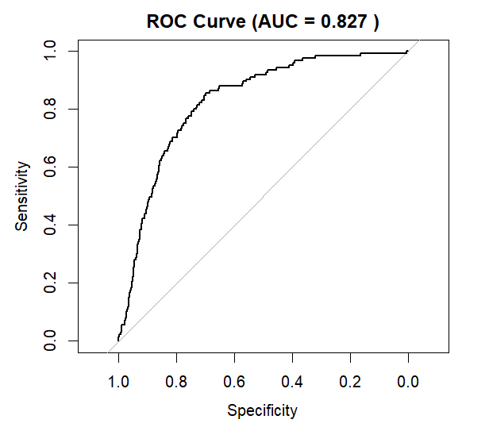

ROC Curve – Python
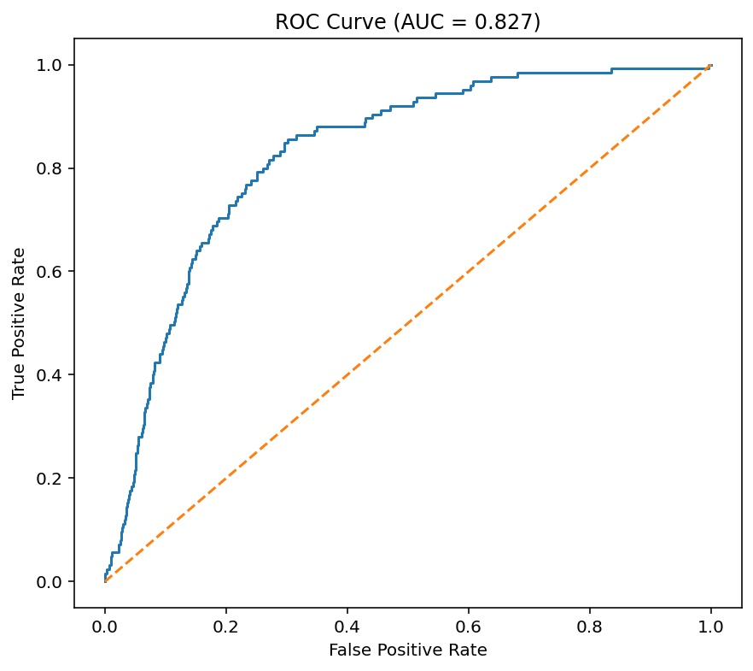

ROC Curve Analysis:
- AUC > 0.8 indicate strong model
  - Good ability to correctly capture stroke and non-stroke cases
- Curve is above the diagonal line (across almost all thresholds) strong predictive ability
- Model captures true stroke cases while not producing excessively large number of FP cases
- Best threshold: 0.04246834
  - Sensitivity = 0.856, Specificity = 0.6985201

Confusion Matrix Heatmap – Python
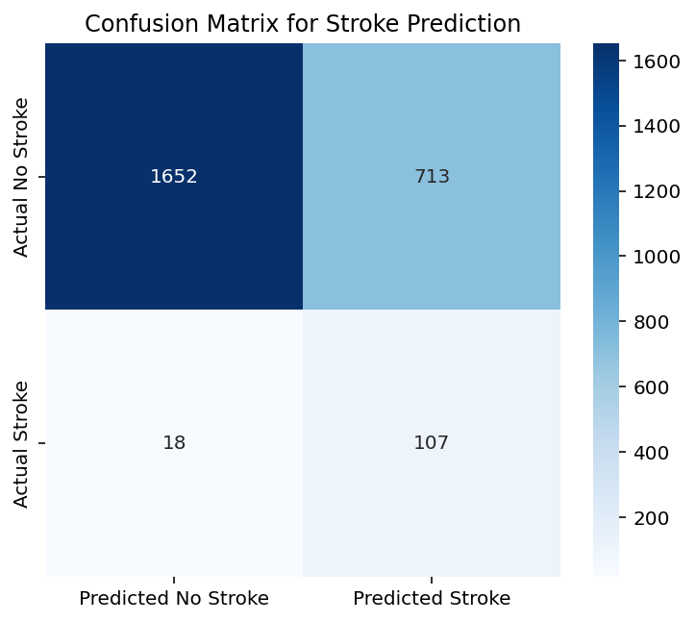

Main-effects Model Key observations:
- Age is highly significant
  - $\left(1.0764 - 1\right)× 100≈8$
  - For each additional year, the stoke rate increases by about 8%, which is a strong effect
  - p-value = 2e-16
  - The entire confidence interval is above 1 in both models, which indicates the effect is statistically significant
- Hypertension is significant
  - $\left(1.8740 - 1\right)× 100≈87$
  - Individuals with hypertension have approximately 87% higher chance of stroke compared to those without hypertension
  - Entire confidence interval above 1: 1.20 – 2.89
- Avg Glucose Level is significant
  - Small effect per unit (Odd Ratio = 1.0041)
  - p-value = 0.017
  - Higher glucose levels associated with stroke rate
Age was found to be a highly significant predictor of stroke. The odds ratio for age was 1.0764, which indicates that for each additional year of age, the odds of stroke increase by approximately 8%: ($\left(1.0764 - 1\right)× 100≈8$). This represents a strong effect, especially because the p-value was extremely small, (p = 2e-16). In both logistic regression models, the entire confidence interval for age was above 1, further confirming that the effect is statistically significant. Hypertension was also a significant predictor of stroke. With an odds ratio of 1.8740, individuals with hypertension had approximately 87% higher odds of stroke compared to individuals without hypertension: ($\left(1.8740- 1\right)× 100≈8$7). The confidence interval for hypertension, ranging from 1.20 to 2.89, was entirely above 1, which supports the conclusion that hypertension is significantly associated with increased stroke risk. Average glucose level was also statistically significant, although its effect size was smaller per unit increase. Its odds ratio was 1.0041 with a p-value of 0.017, indicating that higher glucose levels are associated with increased odds of stroke. Overall, age, hypertension, and average glucose level all showed statistically significant positive associations with stroke risk, with age and hypertension showing especially notable effects.

Model 2: Interaction Model
Model Summary
  - Predictors: Gender, age, bmi, heart_disease, hypertension, avg_glucose_level
  - Dependent Variable: Stroke
  - Interaction terms: age:bmi, bmi: avg_glucose_level
  - Observations: 2491
  - Degrees of Freedom (Model): 8
  - Degrees of Freedom (Residual): 2482
  - R Training time: 0.2322 seconds
  - Python Training time: 0.0168 seconds

Coefficients Table – R
Variable | Estimate | Std. Error | z value | p-value
Intercept | -9.4912 | 2.5608 | -3.7060 | 0.0002
Gender (Male) | 0.1148 | 0.2007 | 0.5720 | 0.5674
Age | 0.1237 | 0.0346 | 3.5720 | 0.0004
BMI | 0.0628 | 0.0803 | 0.7820 | 0.4343
Heart Disease (1) | 0.4254 | 0.2778 | 1.5310 | 0.1257
Hypertension (1) | 0.5838 | 0.2211 | 2.6410 | 0.0083
Avg Glucose Level | -0.0149 | 0.0085 | -1.7520 | 0.0798
Age × BMI | -0.0018 | 0.0011 | -1.6210 | 0.1050
BMI × Avg Glucose Level | 0.0006 | 0.0003 | 2.2940 | 0.0218

Null deviance: 979.85 on 2490 degrees of freedom
Residual deviance: 761.28 on 2482 degrees of freedom
Number of Fisher Scoring iterations: 8

Coefficients Table – Python
Variable | Coefficient | Std. Error | z-value | p-value | Lower 95% CI | Upper 95% CI
Intercept | -9.4912 | 2.561 | -3.706 | <0.001 | -14.510 | -4.472
Gender (Male) | 0.1148 | 0.201 | 0.572 | 0.567 | -0.279 | 0.508
Heart Disease | 0.4254 | 0.278 | 1.531 | 0.126 | -0.119 | 0.970
Hypertension | 0.5838 | 0.221 | 2.641 | 0.008 | 0.150 | 1.017
Age | 0.1237 | 0.035 | 3.572 | <0.001 | 0.056 | 0.192
BMI | 0.0628 | 0.080 | 0.782 | 0.434 | -0.095 | 0.220
Age × BMI | -0.0018 | 0.001 | -1.621 | 0.105 | -0.004 | 0.000
Average Glucose Level | -0.0149 | 0.009 | -1.752 | 0.080 | -0.032 | 0.002
BMI × Average Glucose Level | 0.0006 | 0.000 | 2.294 | 0.022 | 0.000088 | 0.0010

Odds Ratios
 | Odd Ratio – R | Odds Ratio – Python
Intercept | 7.5517e-05 | 0.000076
Gender (Male) | 1.1216 | 1.1216
age | 1.1317 | 1.1317
bmi | 1.0648 | 1.0648
heart_disease (1) | 1.5302 | 1.5302
hypertension (1) | 1.7929 | 1.7929
avg_glucose_level | 0.9852 | 0.9852
age:bmi | 0.9982 | 0.9982
bmi:avg_glucose_level | 1.0006 | 1.0006

Odds Ratio Confidence Intervals
R Python
 | 2.5% | 97.5% | Lower 95% CI | Upper 95% CI
Intercept | 4.6754e-07 | 0.0101 | 0.0000005 | 0.0114
Gender (Male) | 0.7548 | 1.6603 | 0.7569 | 1.6621
age | 1.0588 | 1.2118 | 1.0574 | 1.2111
bmi | 0.9075 | 1.2413 | 0.9098 | 1.2462
heart_disease (1) | 0.8716 | 2.5997 | 0.8878 | 2.6375
hypertension (1) | 1.1536 | 2.7491 | 1.1624 | 2.7654
avg_glucose_level | 0.9688 | 1.0017 | 0.9689 | 1.0018
age:bmi | 0.9961 | 1.0004 | 0.9960 | 1.0004
bmi:avg_glucose_level | 1.0001 | 1.0011 | 1.0001 | 1.0011

Accuracy Test – R
1. Threshold: 0.05
- Sensitivity: 0.8080
- Specificity: 0.7328
- Accuracy: 0.7365
- Model correctly identifies about 81% of actual stroke cases
- Smaller FN, higher FP
- Confusion Matrix:
Actual
Predicted | 0 | 1
0 | 1733 | 24
1 | 632 | 101

2. Threshold: 0.1
- Sensitivity: 0.6320
- Specificity: 0.8457
- Accuracy: 0.8349
- Model detected a more balanced proportion of stroke cases
- Fewer FP
- Confusion Matrix:
Actual
Predicted | 0 | 1
0 | 2000 | 46
1 | 365 | 79

3. Threshold: 0.2
- Sensitivity: 0.2640
- Specificity: 0.9476
- Accuracy: 0.9133 (highest)
- Good at identifying non-stroke individuals
- Fewest FP, but highest FN only 26.4% of stroke cases detected
- Confusion Matrix:
Actual
Predicted | 0 | 1
0 | 2241 | 92
1 | 124 | 33

4. Best Threshold (from ROC curve): 0.04872067
- Sensitivity: 0.8240
- Specificity: 0.7294
- Accuracy: 0.7341
- Confusion Matrix:
Actual
Predicted | 0 | 1
0 | 1725 | 22
1 | 640 | 103

Accuracy Test – Python
1. Threshold: 0.05
- Sensitivity: 0.8080
- Specificity: 0.7328
- Accuracy: 0.7365
- Confusion Matrix:
Actual
Predicted | 0 | 1
0 | 1733 | 24
1 | 632 | 101

2. Best Threshold (from ROC curve): 0.048734
- Sensitivity: 0.8160
- Specificity: 0.7294
- Accuracy: 0.7337
- Confusion Matrix:
Actual
Predicted | 0 | 1
0 | 1725 | 23
1 | 640 | 102

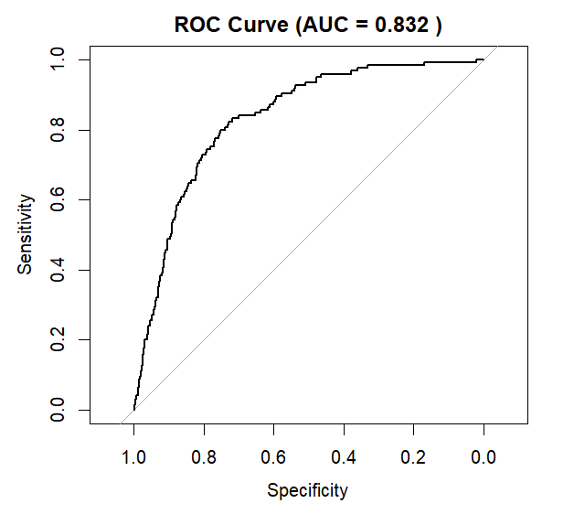
ROC Curve – R

ROC Curve – Python
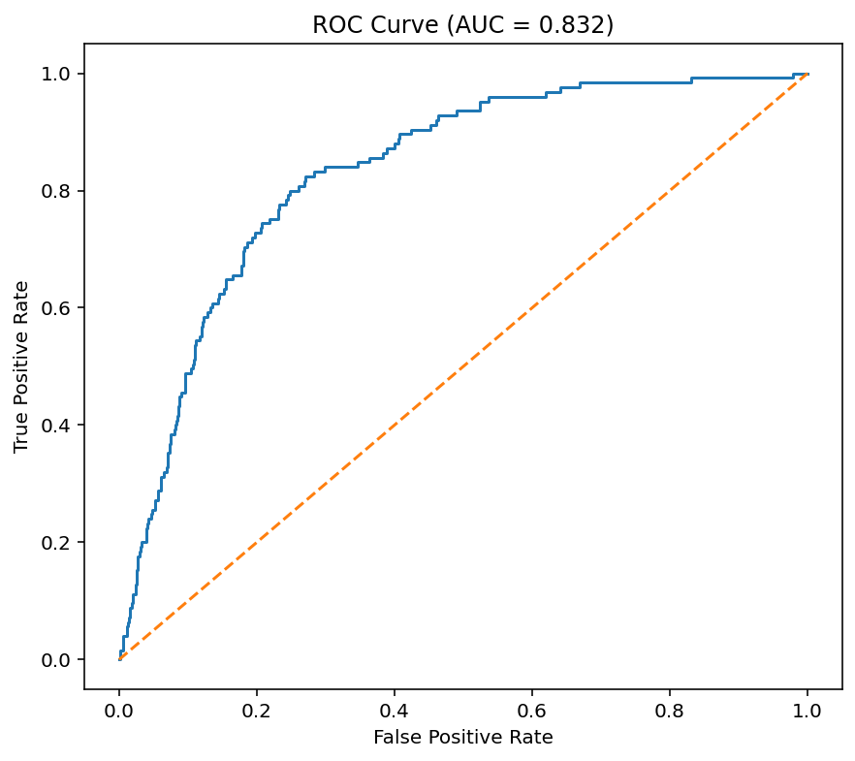

ROC Curve Analysis:
- AUC > 0.8 indicate strong model (greater than main-effects)
  - Good ability to correctly predict stroke and non-stroke cases
- Model captures true stroke cases while not producing excessively large number of FP cases
- ROC combined with the AIC comparison result, the interaction effects may have helped capture more complex relationships associated with stroke prevalence (though it’s a slight increase), improving model fit and classification ability.
- Best threshold: 0.04872067
  - Sensitivity = 0.824, Specificity = 0.7293869

Confusion Matrix Heatmap - Python
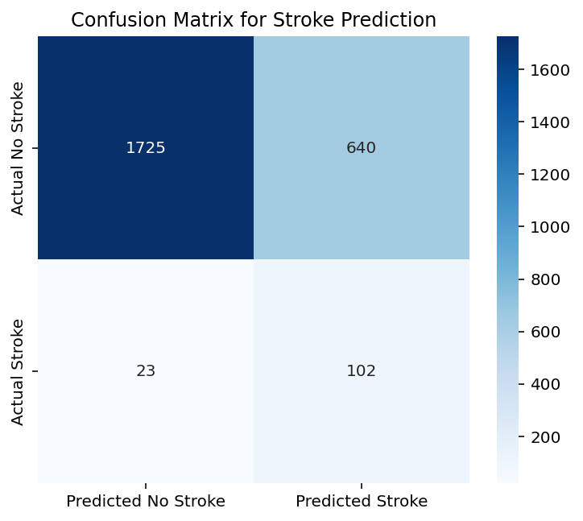

Interaction Model Key observations:
- Age is highly significant
  - p-value = 0.0035
- Hypertension is significant
  - p-value = 0.0083
- bmi:avg_glucose_level is significant
  - p-value = 0.0218
  - Although BMI is not a significant predictor independently, it becomes more influential when glucose levels rise
- Age:bmi not significant
  - p-value = 0.1050
  - The effect of age on stroke risk does not significantly change across BMI levels

Model Comparison
AIC:
- Main-effects Model: 784.58
- Interaction Model 2: 779.28
Interpretation: The Interaction Model has lower AIC score, so we observe that the interaction model demonstrates modest improvement in fit compared to the main-effects model. This suggests that combined effects among predictors (interactions) likely capture meaningful stroke relationships.

Similarities
- Lower threshold more stroke-positive predictions (more false positives)
- Higher threshold fewer stroke-positive predictions, more false-negatives (bad)
- Tradeoff: With higher thresholds, accuracy and specificity increased but sensitivity decreased
  - Since the dataset contains far more non-stroke cases than stroke cases (about 5%), a model can achieve high accuracy by predicting most cases as stroke-negative poor stroke detection (higher FN)
- Given the medical context of stroke prediction, thresholds emphasizing sensitivity may be more appropriate because identifying high-risk individuals is often more important than minimizing false positives.

